**TCP/IP CHATROOM - FULL DUPLEX**

**EXPERIMENT - 5**

Sub code : 18CSC302J

CSE F1

Computer Networks

REG. NO. : RA1811003010344

Name : Vikash Mishra

Date : 12/09/20

TCP - Client

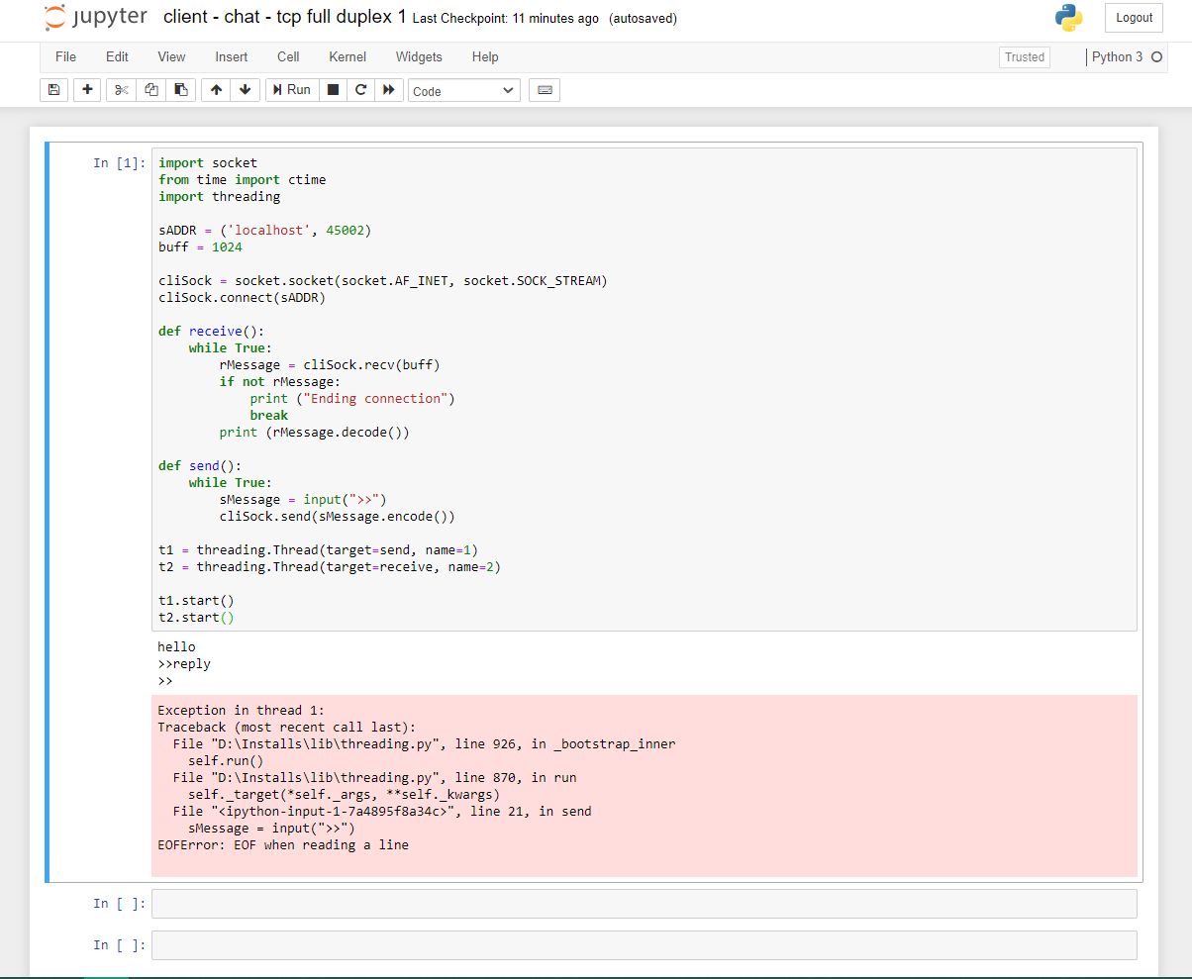

TCP - SERVER

